 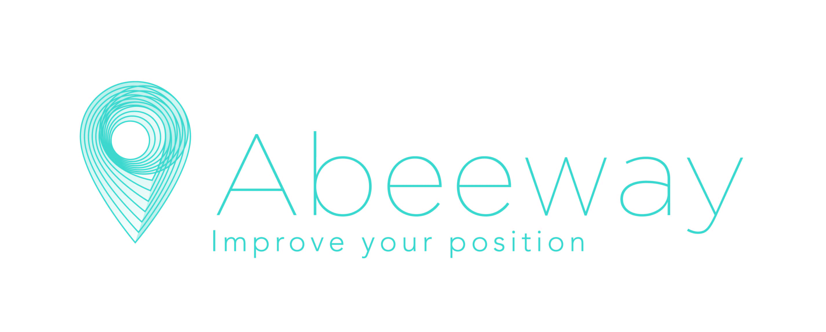

**Internship - Progress Report**

**Abeeway**

Aristote A 2000 rte Lucioles, 06410 Biot

[www.abeeway.com](http://www.abeeway.com)

Name : Fahadh Mohamed JAHEER HUSSAN – A3

Student ID : 62720

Tutor : Stéphane BOUDAUD, R&D Senior Director of Engineering

Referent teacher : Saad EL JAOUHARI, Professor, PhD

**Introduction:**

Abeeway is a top provider of geolocation solutions, specializing in asset tracking and location technologies for IoT applications. They offer innovative devices and software for industries like logistics and smart cities, enabling accurate and reliable asset tracking with long battery life.

I joined Abeeway on March 11th as an intern in the role of Junior Software Engineer. Abeeway is developing a new firmware called Asset Tracking 3 (AT3), which includes a new technology - LTE.

My responsibility entails testing this firmware using Python and displaying the results through a Qt application.

**Objective of Internship:**

The subject of my internship at Abeeway revolves around the development of the Asset Tracker 3 (AT3) firmware, a generic asset tracker application designed to enhance location tracking capabilities using acquisition technologies such as Bluetooth, WiFi, and GPS. The AT3 is fully configurable and different from standard products, allowing it to be customized according to the specific needs of customers.

This firmware is designed to transmit location data using LORA and LTE for further processing and analysis. Within this project context, my role primarily involves testing the functionalities of the firmware. Over the past two months, I have been responsible for ensuring that these functionalities operate correctly.

This includes verifying that location tracking works accurately using the

designated acquisition technologies, confirming that the correct payload is successfully transmitted to the LoRaWAN gateway etc...

Abeeway offers a range of trackers, including the Micro Tracker, Compact Tracker, Industrial Tracker, Smart Badge, and Geolocation Module. My focus lies specifically on the Compact Tracker model.

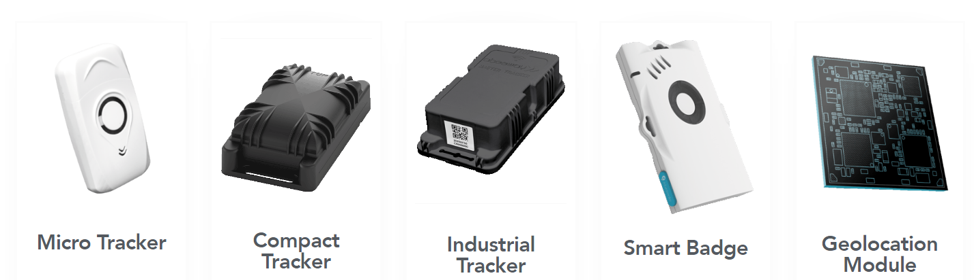

**Tasks and Timeline:**

**1st week and 2nd week :**

During the first and second weeks of my internship, I focused on familiarizing myself with Abeeway products, particularly the various trackers offered by the company. This involved extensively reading documentation related to Abeeway products, including specifications for all trackers. Additionally, I began working on the Qt framework and familiarized myself with Qt Designer.

**3rd week:**

In the third week, I progressed to practical tasks by flashing firmware and BLE stack onto the Compact Tracker board.

I also delved into learning the AT3 commands, flashed firmware onto the Evaluation Kit (EVK) board, and combo

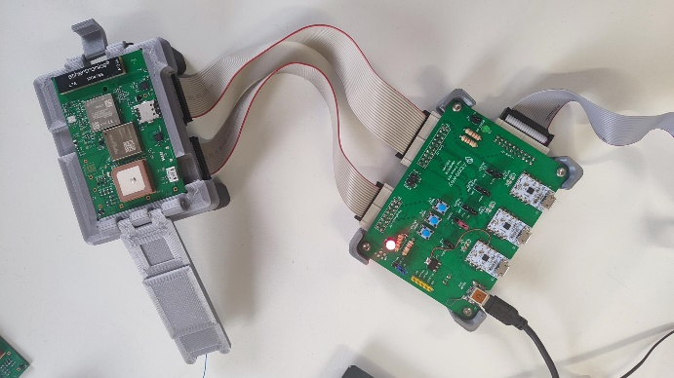 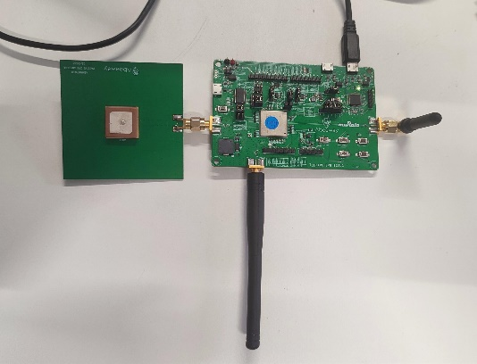

Combo compact Tracker EVK

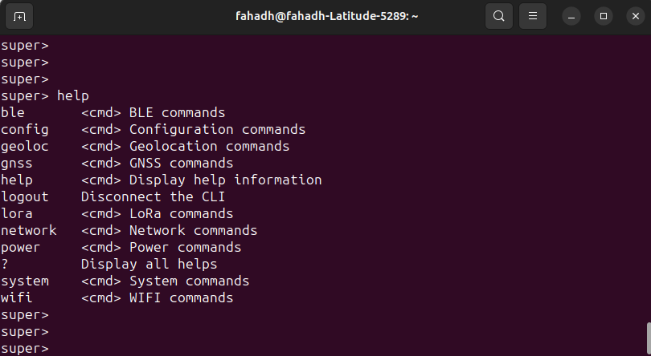

AT3 (Asset Tracker 3) Commands

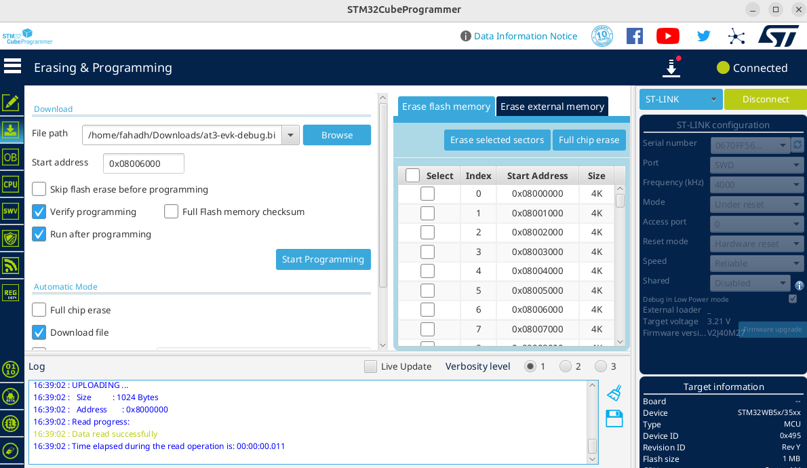

Flashing AT3 firmware in the Combo Tracker using STM32cubeprogrammer

The EVK serves as an evaluation platform for the ultra-low power geolocation module developed in collaboration between Murata and Abeeway. It provides comprehensive access to all module functionalities, including radio systems, digital interfaces, GPIOs, power management circuitry, and sensors.

**4th week and 5th week:**

During the fourth and fifth weeks, I focused on studying the AT3 documentation in detail and commenced writing Python scripts to conduct initial tests on the AT3 firmware running on the EVK board.

These tests aimed to assess the timing between different acquisition events, such as BLE, WiFi, or GPS, and ensure they occur at the expected intervals. Various test cases were developed to cover different scenarios, such as static or motion conditions of the tracker.

For Example,

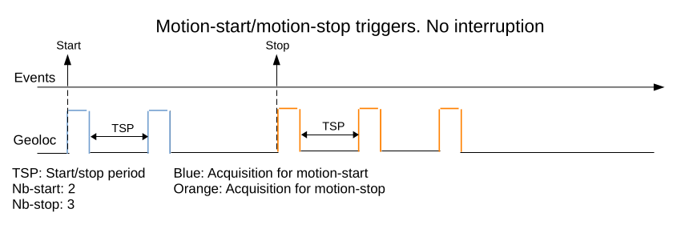 Test case of testing timing interval

I wrote a program to measure the timing intervals between two acquisitions. If the measured timing interval is equal to the expected timing interval. The test is passed. Like this I have tested more test cases.

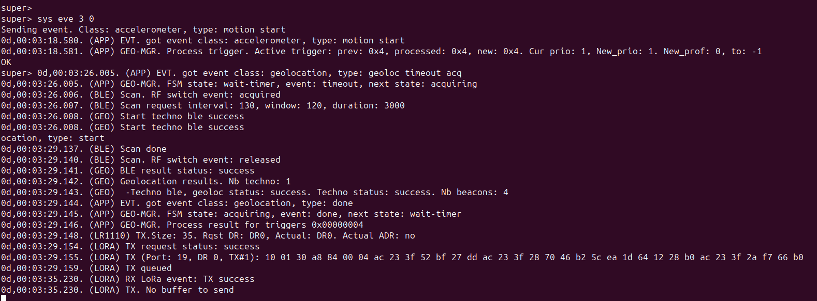 Example of ble acquisition and its payload in AT3

**6th week and 7th week:**

In the sixth and seventh weeks, I focused on developing efficient Python programs for automated testing of geolocation timing functionalities. I wrote a program that processes JSON files, each containing different states for the tests, with some states having specific conditions to check.

The program tests these conditions and writes the results to a text file, indicating whether each state passed or failed. This program is referred to as a **state machine.** I can use this generic program for different variations of the test.

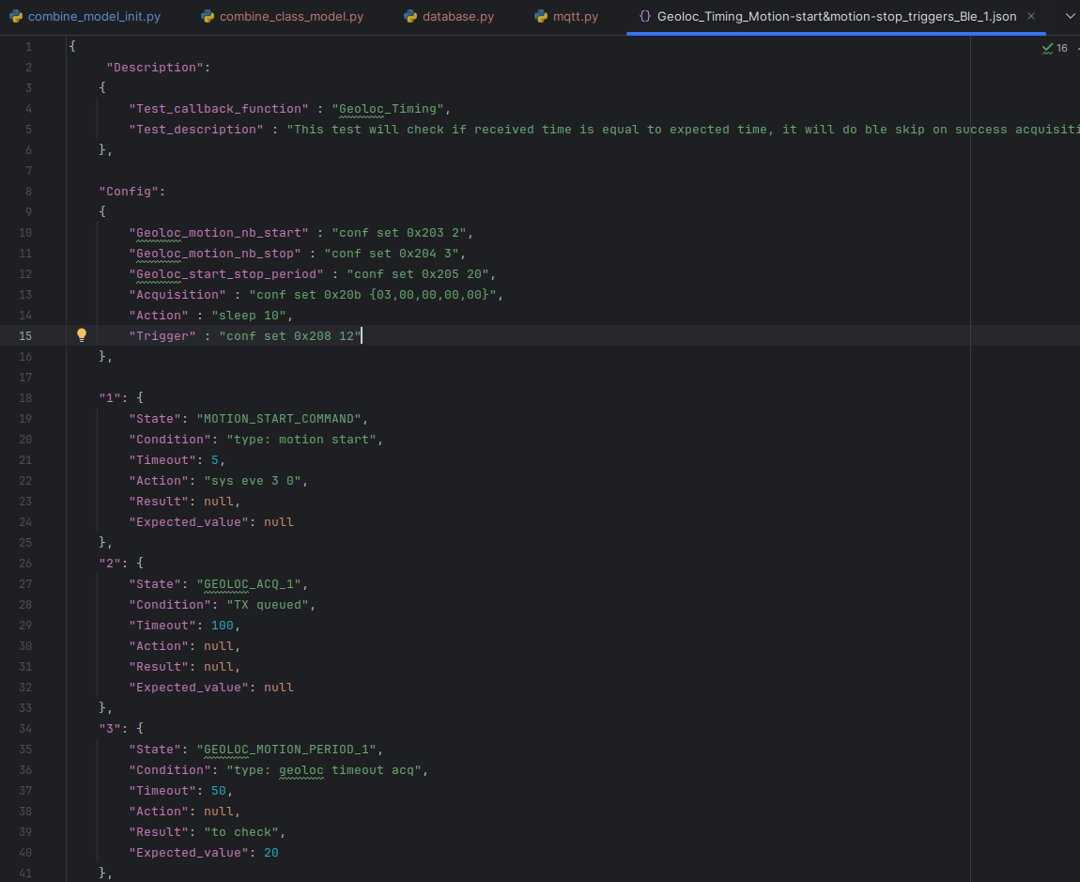

Json file for tesing geoloc timing

I created various JSON files for all the test cases. By passing all these JSON files through a single Python program (the state machine), I use this state machine where different test cases can be processed, and the results are written to a text file.

For the first test, I evaluate the timing aspects under different acquisition scenarios using the state machine. The benefit of this efficient program is highly generic, saving time and ensuring scalability for future testing needs.

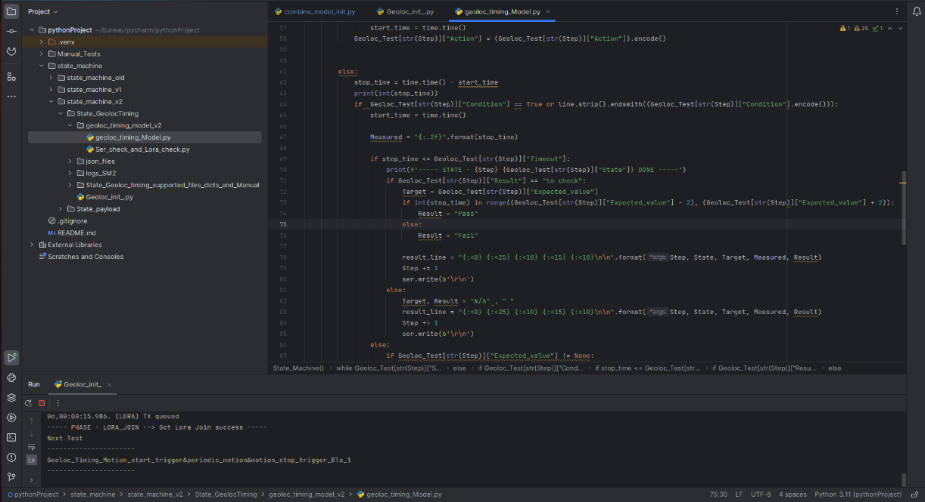

Generic program for testing (State Machine)

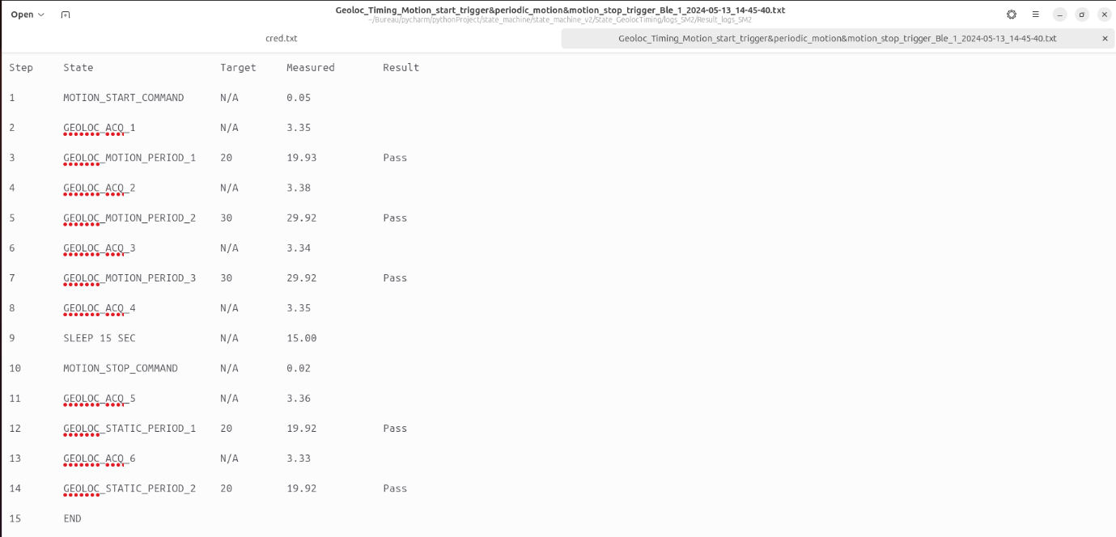 Result file of testing timing intervals

**8th week and 9th week:**

In the eighth week, I proceeded to conduct a second round of testing, specifically focusing on the payload of each acquisition event using state machine. I verified whether the payload generated by the AT3 firmware matched the expected payload for each acquisition method using the state machine.

Various test cases were devised to encompass different payload scenarios and ensure the accuracy of data transmission to the LoRa gateway.

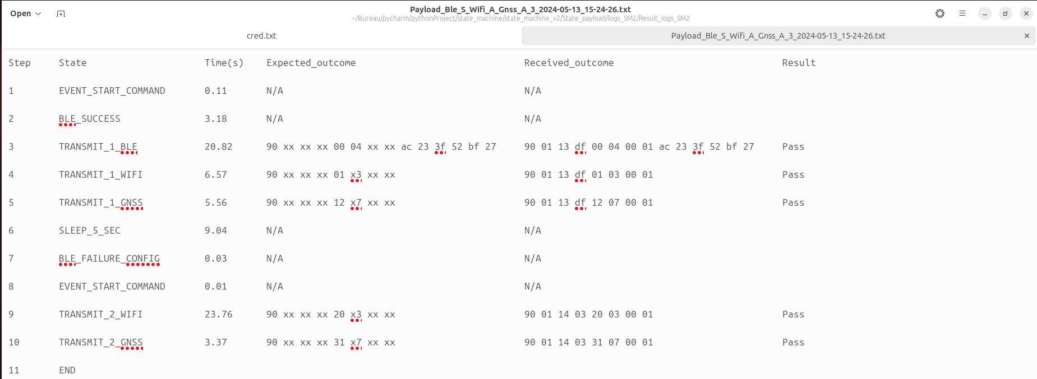 Result file of testing payloads

**Gantt Chart:**

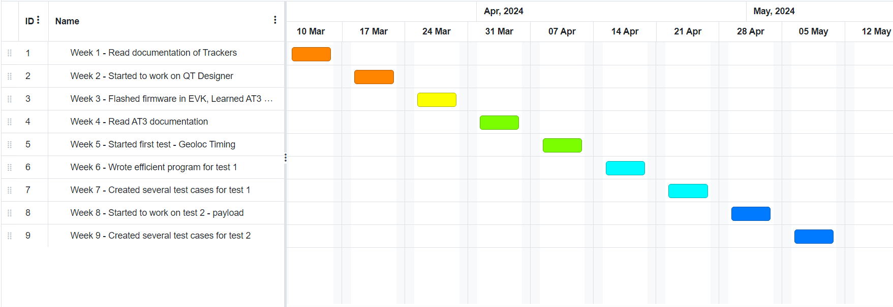

**Initial changes and difficulties:**

During the first week of my internship, my primary task was to learn Qt in order to create graphical user interfaces (GUIs) for testing purposes. However, as the internship progressed, the focus shifted towards testing activities in subsequent weeks.

One notable difficulty encountered initially was adapting to the office environment. However, it's important to note that this challenge did not have any adverse impact on my work or the company's operations.

**Conclusion :**

Over the past two months, my internship at Abeeway has been a rewarding experience. From learning about their products and the Qt framework to testing the Asset Tracker 3 firmware with Python, I've gained valuable skills. Despite initial challenges, I have adapted and contributed effectively.

In the coming months, I plan to conduct various tests using databases, MQTT, LoRa, and more. Additionally, I will create a Qt application to display all the test results. I'm grateful for the opportunity and look forward to applying what I've learned in the future.